COPPER INSECTS
STARTER PACK<br/>

www.home2garden.co.uk TRADE RRP
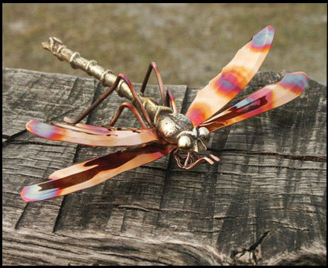 | 4 Large Springwire Dragonfly  Springwire Lengh 50cm (DF-LCS)  12 Medium Springwire Dragonfly  Springwire Lengh 50cm (DF-MF)  24 Small Springwire Dragonfly  Springwire Lengh 50cm (DF-S1) | £21.25  £8.50  £5.65 | £49.95  £19.99  £12.99
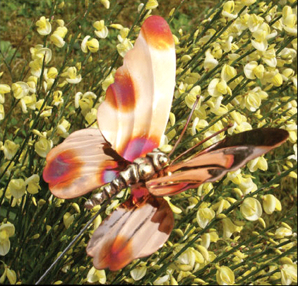 | 12 Small Springwire Butterfly  Springwire Lengh 50cm (BF-M1) | £5.65 | £12.99
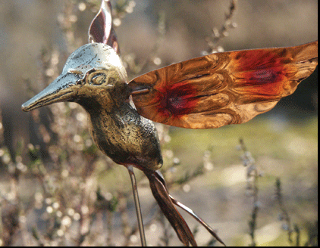 | 6 Med Springwire Humming Bird  Springwire Lengh 50cm (CB-MS) | £8.50 | £19.99
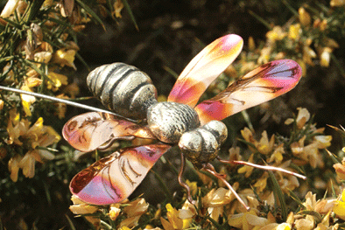 | 12 Medium Springwire Bee  Springwire Lengh 50cm (BC-MS) | £8.50 | £19.99

Starter Pack Includes:
- 70 Copper Insects
- FREE loan of Stand (accommodates up to 27 products)
- FREE delivery

Total cost £ 425.60
Trade prices exclusive of VAT
On offshore orders shipping charges may apply

Home to Garden Ltd .8A Lower Road Chorleywood Herts, <br/>WD3 5LH
<br/>Tel/Fax: 01923 467 372, Mob 07980 893605: Email: home2gardenltd@yahoo.co.uk<p/>

